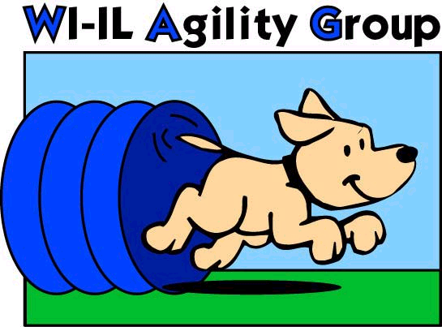

►► Printed 08/27/25 Subject to change without notice ◄◄
Confirm dates at www.wagagility.com or with a WAG instructor
For Class Registration information, email wagclassregistrar@gmail.com

Session | Instructor& Member sign-up | Current Student sign-up | New Student sign-up | Session Start  (week of) | Session End  (week of)
1  9 weeks | Dec 8, 2025 | Dec 15 | Dec 22 | Jan 4, 2026 | March 1, 2026
2  8 weeks | Feb 9, 2026 | Feb 16 | Feb 23 | March 8, 2026 | April 26, 2026
3  8 weeks | April 6, 2026 | April 13 | April 20 | May 3, 2026 | July 5, 2026
4  8 weeks | June 15, 2026 | June 22 | June 29 | July 12, 2026 | Aug 30, 2026
5  8 weeks | Aug 17,2026 | Aug, 24 | Aug 31 | Sep 13, 2026 | Nov 1, 2026
6  9 weeks | Oct 12, 2026 | Oct 19 | Oct 26 | Nov 8, 2026 | Jan 24, 2027

No classes the week of a major holiday: Memorial Day, Labor Day, 4th of July, Thanksgiving, Christmas, New Years Day

No classes on Thursday evenings prior to AKC trials.

**Dates subject to change**
Check out our website for complete & updated details:
www.wagagility.com
Trials  Fun Matches  Classes  Ring Rental  Seminars

2807 N US HWY 12
Spring Grove, IL 60081

Climate Controlled!

