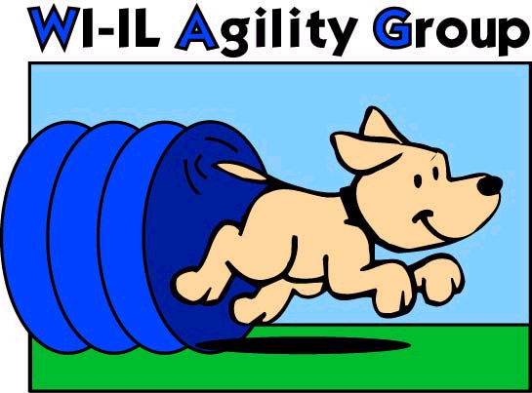

►► Printed 09/06/23 Subject to change without notice ◄◄
Confirm dates at www.wagagility.com or with a WAG instructor
For Class Registration information, email classregistration@wagagility.com

Session | Member sign-up | Current Student sign-up | New Student sign-up | Session Start  (week of) | Session End  (week of)
1  9 weeks* | Jan 2, 2024 | Jan 8, 2024 | Jan 15, 2024 | Jan 21, 2024 | March 17, 2024
2  8 weeks | March 4 | March 11 | March 18 | March 24 | May 12
3  8 weeks | April 29 | May 6 | May 13 | May 19 | July 21
4  8 weeks | July 8 | July 15 | July 22 | July 28 | Sep 22
5  8 weeks | Sep 9 | Sep 16 | Sep 23 | Sep 29 | Nov 17
6  9 weeks* | Nov 11 | Nov 18 | Nov 25 | Dec 1 | Feb 9, 2025

No classes the week of a major holiday: Memorial Day, Labor Day, 4th of July, Thanksgiving, Christmas, New Years Day

No classes on Thursday evenings prior to WAG 3 day AKC trials.
* Sessions 1& 6 include one extra week (9th week) for make-up classes, if needed, due to possible inclement weather cancellations

**Dates subject to change**
Check out our website for complete & updated details:
www.wagagility.com
Trials  Fun Matches  Classes  Ring Rental  Seminars

2807 N US HWY 12
Spring Grove, IL 60081
815–675–9300
Climate Controlled!

